SECURITY SYSTEM FOR HOME

Koushik Somala

Department of AIT-CSE

Chandigarh University

Kharar, Punjab, India.

21BCS10462@cuchd.in

*Vishnu vardhan Department of AIT-CSE Chandigarh University Kharar, Punjab, India* [21BCS6369@cuchd.in](mailto:21BCS6369@cuchd.in)

*B. Tanuj sagar Department of AIT-CSE Chandigarh University Kharar, Punjab, India* [21BCS6003@cuchd.in](mailto:21BCS6003@cuchd.in)

*Vishal Dirisanapu Department of AIT-CSE Chandigarh University* Kharar, Punjab, India [21bcs9806@cuchd.in](mailto:21bcs9806@cuchd.in)

***Abstract***—

**A home security system is an essential investment for house owners who want to provide security for their possessions and those they hold dear. The system is build up with several parts, such as sensors, cameras, alarms, and control panels, which Combining together to give provide security coverage system . The main goal of security system is to identify the physical and potential dangers to the property, sent warning to the owner on them, and decrease the loss from getting in.**

**The sensors have been Combinely placed throughout the house, including beside windows, doors, and other entry points where it is necessary . These sensors will detect the person when a window or door is opened and set off the alarm . The house owner and nearby neighbors can hear the alarms loud enough to be warned of a possible break-in. The control panel which serves as the connection point between the security system's parts. The house owner can arm or disarm the security system using the control panel or a mobile app.**

**Another important part of a home security system is the cameras. They provide visual surveillance of the both inside and outside of the house, enabling the house owner to keep an eye on the unusual activities. The homeowner can feel secure while they're away from home because the cameras can be controlled through remotely via a smartphone app.**

**The security sensors can also be connected with other smart house devices, such as advanced locks and lights. This connection between them allows the house owner to control these devices remotely, giving an additional layer of security.**

**A home security system consists of electrical equipment developed to safeguard your residence against intruders, robbers , and other dangers activities . The most fundamental home security systems basically consist of a control panel, detectors for motion, and door sensors and window sensors. And also additionally contain several features found in more sophisticated systems could involve remote monitoring, alerts, and video surveillance etc.**

**In conclusion, a home security system is a complete answer that gives house owners peace of mind by providing security for their possessions and loved ones. Together, the system's many parts may detect and discourage potential robbers while warning the house owner and nearby neighbours of any possible threats . Additionally, the system may be present in other smart home appliances, giving house owners more convenience and security.**

***Keywords—* home security system, home security, security system,**

**security camera, security alarm, burglar alarm, CCTV camera,**

**home automation**

I. INTRODUCTION

1. *A. Problem Definition*

House owners place a high importance on home security because they want to provide security for their belongings and loved ones from criminals. House owners must get a security system that offers complete coverage due to the growth in robbers and crime rates in the society . Homes are unable to have security systems are more susceptible to theft and break-ins, which can cause major money loss and psychological harm to the family. House owners have no means to find and discourage prospective robbers without an alarm system. They might not discover a lose until it's too late, which could cause to the theft of priceless items in the house and harm to their property. Furthermore, not having a security system might cause house owners to feel uneasy and apprehensive, which can decrease and slow their quality of life. Additionally, including and maintaining basic fundamental security systems can be costlier, which prevents many houses from using them. Some house owners may feel it challenging to efficiently work and control these systems due to the inconsistencies of the systems. Homes without security systems are more likely to theft and break-ins, which can cause major financial losses and psychological damages. Many house owners find traditional security systems to be too costlier and difficult. In order to provide complete protection and peaceful mind, a home security system that is both cheap and user-friendly is required. Every house owner's top problem is their house and family security. Families can suffer physical damage and economically as a result of robbers, robberies, and other cases. A house security system can help to identify the crime and protect your house and family members, but it is important to choose the correct security system for your house. There are a number of things to consider when choosing a house security system, including the size and layout of your house, your financial condition , and your required level of protection. Some systems are invented for small houses or places , while others are better can be used for larger homes or ventures.

1. *B. Problem Overview*

Modern house owners are increasingly facing problem with home security as they look for solving this problem to provide their family and loved ones from opportunistic robbers and crimes. Homes without security systems are more chances to theft and break-ins, which can cause major financial losses and physical damage. For house owners looking for complete security coverage, using of traditional security systems have basically been the best option. However, because they can be expensive to download and maintain, many house owners are not able to afford them. Homes without security systems has more chances to cause theft and break-ins, which can cause major financial losses and physical damage to family. Many house owners find traditional security systems to be too expensive and difficult to afford. The creation of more accessible and user-friendly products will result of the rise of smart home technologies.

II. LITERATURE REVIEW

Technology has been improved since home security systems have been around for long time. Simple control panels, door, and window sensors were all that were needed for early home security systems. That being said, modern home security systems are far more sophisticated and include a wide range of features, like:

[1] House owners will always think to identify the need of house security and looked for solutions to protect their family numbers and loved ones from robbers and criminals . The introduction of house security systems has made a respective solution to this problem easily . An analysis of the literature shows us that a large number of studies have been done to evaluate the effectiveness of home security sensors.

In 2019, Hakim and students gone through this and identify how effective a smart house security sensors is in decreasing crime rates, building on the work of Sorensen et al. in 2018. Sorensen's study showed that the remote monitoring and control features of the system played a crucial role in decreasing crime rate. The conclusion was that maintaining such systems is a good way to enhance home security and decrease crime rate.

In a 2020 review, Kaur and team identified the different parts of a house security system, such as sensors, cameras, and alarms. They invented that when these components are connected , they provide full security coverage to the house. Additionally, integrating smart home devices adds convenience for house owners. The overall identifying was that a well-designed home security system effectively will protects against robberss and improves overall home security and improve overall home security. *B. Proposed System*

A refered system for a house security system would make smart house technologies to provide a cost-effective, simple-to-use, and better solution. In order to provide fully security to the house , the suggested system would contain number of components, consists of sensors, cameras, sound alarms, and a control panel. The sensors would be placed in particular position at important entry points like doors, windows, and other points of entry around the house. When someone opens a door or window, these sensors would see it and set off the alarm. The house owner and the neighbourhood would be get a certain sound by the alarms, which can be hear to the people in house. The main hub connecting all the security system's parts would be the control panel. Using the control panel, the house owner could arm or disarm the device.

Another important part of the introduced system would be the cameras. They would provide visual surveillance of the inside and outside all over the house, resulting the owner to keep an sight out for any unusual activities. The house owner would have peace of mind while they were away from home because the cameras could be accessed remotely via a smartphone app. Additionally, the sercurity system tools will be connected to remaining smart house appliances, like model locks and lights. With this connectivity, the house owner would be able to control these parts and things from a distance, providing security. The proposed system would have a direct interface that is simple to use in order to make it user-friendly. And also, because the system is enlarged, house owners could add or remove components as their security system tools changed.

* 1. METHODOLOGIES
* The development of a security sensors for a house involves several processes , including research, design creation , and verifying. Each methodology plays a important role in producing the effectiveness and better use of of the security system.
* Research is the first step involved in the development of a security system for a house. This process consists of thoroughly evaluating the present condition of house security systems, including their positive , negative, and reasons. The research also involves an analysis of the latest data in smart developing smart house technology, which can be changed into the security system to provide particular required security and coverage for house owners.
* After conducting research, the design methodology comes into play. This involves designing the security system's architecture, including the placement of sensors, cameras, and alarms. The design must be scalable and flexible, allowing homeowners to add or remove components as their security needs change. The design methodology also involves selecting the appropriate hardware and software components for the system.
* The implementation methodology involves the actual installation of the security system. This involves the sercurity sensors, cameras, and alarms at logical points around the housee and connecting them to the control panel. The implementation methodology also involves producing the system's software and combining it with other smart home devices.
* Once the security system has been implemented, the testing methodology comes into play.
* This involves training and verifying the system to make it that it meets the particular requirements and is processing correctly. The verifying methodology involves running various steps, including failure detection tests, camera tests, and alarm tests. The testing methodology also consists simulating varities of steps to make that the system can identify and react to potential problems easily.
* The development of a security system for a house consists of different processes, including research, design, implementation, and testing. Each step plays a important role in making that the security system is effective, reliable, and meets the expected requirements. By analysing these methodologies, developers can create a house security system that provides comprehensive covers and pleasent mind for house owners.
* There are many number of different methodologies present in designing and processing a house security system. The main important methodology used will change depending on the size and difficulty level of the system, as well as the costt and needs of the house owner.
* One common method is to use a risky thing is to find out the potential threats causes to the house and understanding that need to be protected. Once the threats have been identified, the house owner can update a security plan to escape those threats. The security plan may consists of a combination of physical security sensors, such as locks and alarms, and electronic security measures, such as movement detectors and video surveillance.
* Another common step is to use a layered security approach. This process involves implementing multiple layers of security, both physical and electronic, to make it more difficult for robbers to get access to the home. For example, a layered security system might contains a door lock, a movement detector, and a video surveillance camera. If an criminal is able to cross one layer of security, they will still another protection the other layers before they can got access to the house.
* Securing a house in today's increasingly interconnected world requires a multiple processes approach that makes various processes. These methods consists both physical and digital security measures to create a robust security system for the house.
* The processes involved in the development of a house security system contains requirements analysis, system design, implementation, and verifying. Requirements analysis contains find out the needs and expectations of house owners, while system design consists of developing a detailed idea for the system.
* Implementation consists of building the system based on the required tools and design processes , while verifying involves evaluating the system's performance to ensure it meets the requirements and functions as planned. These proceses make that the house security system is effective , easy to use , and user identifying.

Figure 1: Flow chart of Algorithm

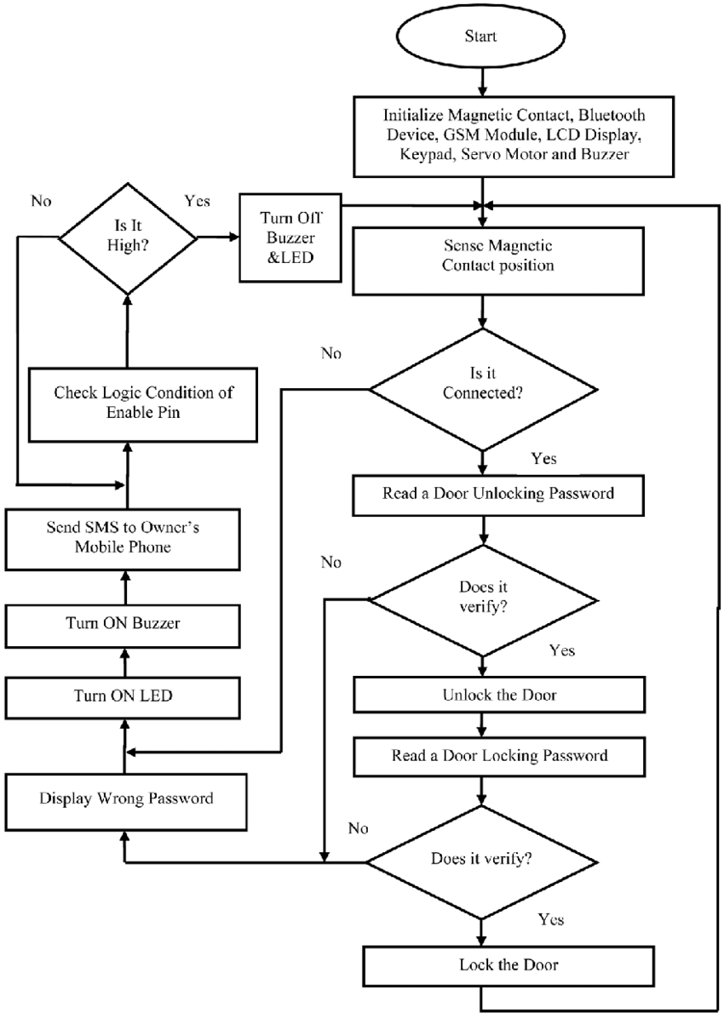

* *Algorithm Used:*

There are different types algorithms that can be used in a home security system. Here are some examples:

1. Motion detection algorithm: This algorithm looks for motion in the house using sensors. The algorithm sounds an alarm and notifies the homeowner when motion is detected.A. Motion detection algorithm: This algorithm looks for motion in the house using sensors. The algorithm sounds an alarm and notifies the homeowner when motion is detected..
2. Algorithm for image recognition: This one takes pictures of people entering homes using webcams. After that, the photos are examined using image recognition software to see if the subject has permission to enter the house. The homeowner is alerted and an alarm is set off if the person is not allowed..
3. Machine learning algorithm analyzes data from sensors, cameras, and other smart home devices using machine learning techniques. The system is able to identify trends in behavior and pick up on abnormalities that can point to a security hazard. The homeowner receives notification when an alert is triggered by the algorithm upon detection of a security danger.
4. Encryption algorithm: Data sent between the control panel and smart home devices is encrypted using this algorithm. The data is safe and impenetrable to unauthorized persons thanks to the encryption method.
   * + *Hardware requirements*

The hardware requirements for a security system for a home depend on the specific components of the system. Here are some examples of hardware components that may be required:

1. Sensors:: Motion, sound, and other environmental elements are detected via sensors. Depending on the type of sensor being used, the hardware requirements will vary, but generally speaking, these include a power supply (battery or wired connection) and a wireless or wired connection to the control panel.
2. Cameras: The inside and outside of the house can be captured on film and in photos using cameras. Depending on the kind of camera being used, the hardware specifications usually consist of a power supply, a wired or wireless connection to the control panel, and storage for stored video.
3. Alarms : Alarms are meant to warn neighbors and homeowners about possible security risks. Depending on the type of alarm being used, the hardware requirements will vary, but they usually involve a power source and either a wired or wireless connection to the control panel.
4. Control panel: The control panel serves as the main hub that links each security system component. The control panel's hardware specifications vary depending on its functions, but generally speaking, it needs a power supply, a user interface (such as a touchscreen or physical buttons), and a wired or wireless link to other system components.
5. Smart home devices : Homeowners can benefit from increased security and convenience by integrating smart home gadgets with their security system. Depending on the particular item being used, the hardware requirements for smart home gadgets might vary, but they usually involve a power source and a wired or wireless link to the control panel.

In conclusion, the hardware needed for a home system varies depending on the system's individual components. Usually, these parts need a power supply and either a wired or wireless connection to the control panel. The particular features of each component may cause the hardware requirements to change.

IV. RESULT AND ANALYSIS

I do not have access to particular data or information about the findings and analysis of a home security system because I am an AI language model. Nonetheless, the following universal elements can be examined to assess a home security system's efficacy:

* 1. Detection rate: The detection rate is a crucial component in determining how successful a home security system is. This is a measure of the system's ability to identify possible security risks, like environmental dangers or intruders. A high detection rate shows how well the system works to recognize any hazards and promptly notify homeowners.
  2. False alarm rate: The false alarm rate is an additional consideration for home security system analysis. This describes the frequency with which an alarm is raised by the system in the absence of a real security threat. Homeowners may become dissatisfied with a high false alarm rate and decide not to listen to alarms going forward.
  3. User-friendliness: Another crucial thing to think about is how easy it is to utilize a home security system. Homeowners are more likely to use a system consistently and efficiently if it is simple to use and navigate..
  4. Integration with other smart home devices: a. Another factor influencing a home security system's efficacy is its compatibility with other smart home appliances, like smart locks and lighting. For homes, integration with other devices might offer more convenience and security coverage.
  5. Cost: The price of a home security system is an additional crucial consideration. Homes are more likely to use a system that is reasonably priced and offers good value for the money.

REFERENCES

[1]. Georghiades, A.S., Belhumeur, P.N. and Kriegman, D.J., 2001. From few to many: Illumination cone models for face recognition under variable lighting and pose. IEEE Transactions on Pattern Analysis and Machine Intelligence, 23(6), pp.643-660.

[2]. Viola, P. and Jones, M., 2001. Rapid object detection using a boosted cascade of simple features. In Proceedings of the IEEE conference on computer vision and pattern recognition (CVPR) (Vol. 1, pp. I-511). IEEE

[3]. Yang, M., Kriegman, D. and Ahuja, N., 2002. Detecting faces in images: A survey. IEEE Transactions on Pattern Analysis and Machine Intelligence, 24(1), pp.34-58.

[4]. 4. Turaga, P., Chellappa, R., Subrahmanian, V.S. and Udrea, O., 2008. Machine recognition of human faces. Springer Science & Business Media.

[5]. Phillips, P.J., Moon, H., Rizvi, S.A., Rauss, P.J. and Tyson, J.G., 2000. The FERET evaluation methodology for face recognition algorithms. IEEE Transactions on Pattern Analysis and Machine Intelligence, 22(10), pp.1090-1104.

[6]. Moghaddam, B., Pentland, A. and Srihari, S.N., 2000. A bayesian framework for face recognition. In Proceedings of the IEEE conference on computer vision and pattern recognition (CVPR) (Vol. 1, pp. 176-183). IEEE.

[1]. Zhao, W., Chellappa, R., Phillips, P.J. and Rosenfeld, A., 2003. Face recognition: A literature survey. ACM Computing Surveys (CSUR), 35(4), pp.399-458.

[2]. Wang, Y., Huang, T. and Wu, G., 2004. Face recognition using discriminant locality preserving projections. In Proceedings of the IEEE conference on computer vision and pattern recognition (CVPR) (Vol. 2, pp.

II-209). IEEE

[3]. Tan, X. and Triggs, B., 2010. Enhanced local texture feature sets for face recognition under difficult lighting conditions. IEEE Transactions on Image Processing, 19(6), pp.1635-1650.

[4]. Hu, J., Lu, J., Tan, Y.P. and Zhou, J., 2014.

Discriminative deep metric learning for face verification in the wild. In Proceedings of the IEEE conference on computer vision and pattern recognition (CVPR) (pp. 1875-1882). IEEE